**Problem Statement 1: [100 marks]**

A company manufactures LED bulbs with a faulty rate of 30%. If I randomly select 6 chosen LEDs, what is the probability of having 2 faulty LEDs in my sample? Calculate the average value of this process. Also evaluate the standard deviation associated with it.

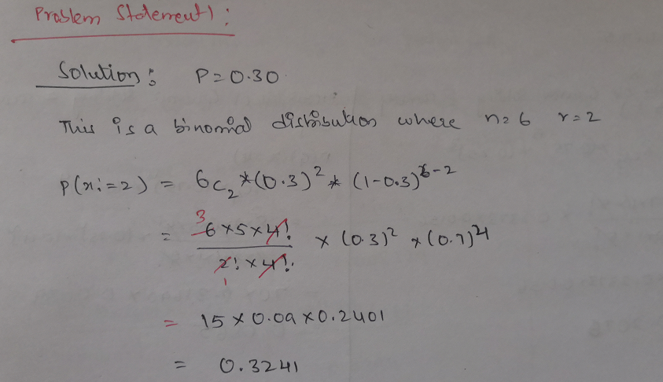

**Problem Statement 2: [100 marks]**

Gaurav and Barakha are both preparing for entrance exams. Gaurav attempts to solve 8 questions per day with a correction rate of 75%, while Barakha averages around 12 questions per day with a correction rate of 45%. What is the probability that each of them will solve 5 questions correctly? What happens in cases of 4 and 6 correct solutions? What do you infer from it? What are the two main governing factors affecting their ability to solve questions correctly? Give a pictorial representation of the same to validate your answer.

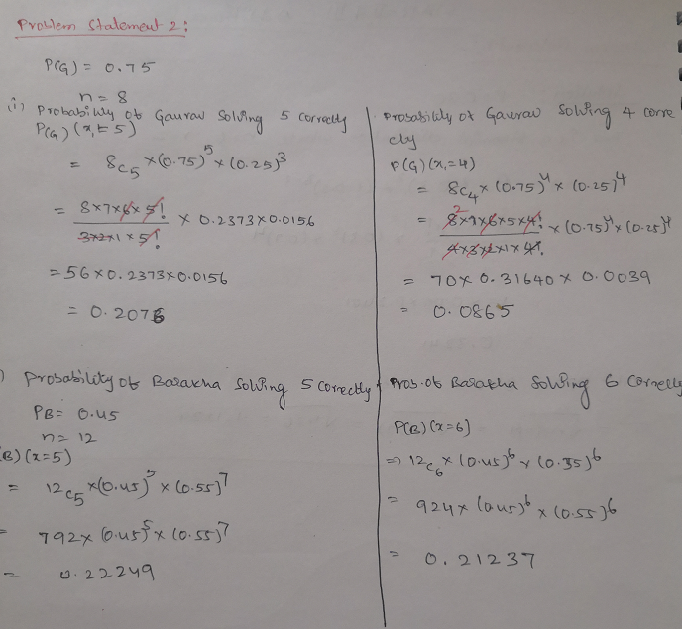

**Problem Statement 3: [100 marks]**

Customers arrive at a rate of 72 per hour to my shop. What is the probability of k customers arriving in 4 minutes? a) 5 customers, b) not more than 3 customers, c) more than 3 customers. Give a pictorial representation of the same to validate your answer.

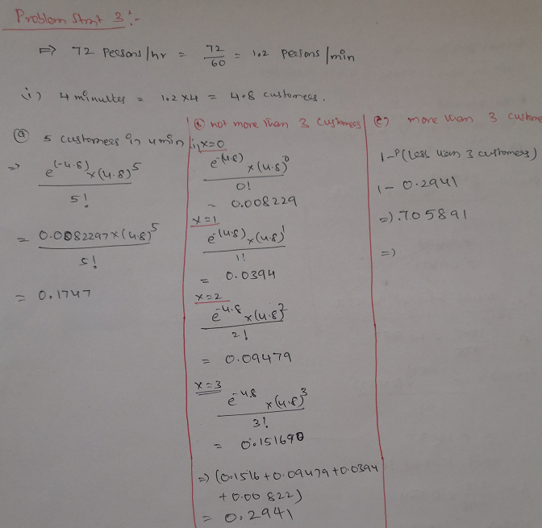

**Problem Statement 4: [100 marks]**

I work as a data analyst in Aeon Learning Pvt. Ltd. After analyzing data, I make reports, where I have the efficiency of entering 77 words per minute with 6 errors per hour. What is the probability that I will commit 2 errors in a 455-word financial report?

What happens when the no. of words increases (in case of 1000 words) or decreases (255 words)? How is the λ affected? How does it influence the PMF? Give a pictorial representation of the same to validate your answer.

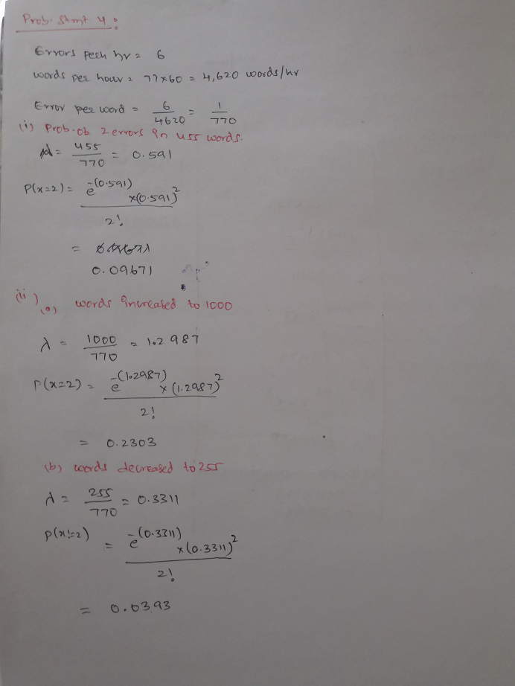

**Problem Statement 5: [100 marks]**

The current measured in a copper wire is modelled by a continuous random variable 𝑋. 𝑋 is in milliamperes. Assume that the range of *X* is [0, 20 mA]. The probability density function is given by, 𝑓(𝑥) = 0.05 for 0≤𝑥≤20. What is the probability that a current measurement is less than 10 milliamperes? Draw the PDF and the CDF diagrams as well.

